

**Rapid Rescue**

**Theme: E Ambulance**

|  |  |  |
| --- | --- | --- |
| **FACULTY :** | **MISS TEZEEN ANIS** | |
| **BATCH :** | **2303F OR 2307A** | |
| **PROJECT :** | **RAPID RESCUE <THEME E ABULANCE >** | |
| **S. NO.** | **ENROLLMENT NO.** | **STUDENT NAME.** |
| **1.** | * **1447789** | **ARADHNA** |
| **2.** | * **1445789** | **MUSFIRAH** |
| **3.** | * **1454210** | **MADIHA** |
| **4.** | * **1444450** | **JAVERIA SHEIKH** |

**1.Acknowledgment:**

*The first, we would like to express my special thanks of gratitude to my teacher MISS TEZEEN ANIS who helped a lot in finalizing this project within the limited time frame, valuable counseling and assistance for the accomplishment of this project.*

*Secondly, we would also like to thanks the TECHWIZ team at Aptech Head Office, who gave as the opportunity to do this interesting and wonderful project about RAPID RESCUE*

*Thirdly, we also thank the e-project team for giving this task to us. Following are the benefits of this Project:*

* *Re-enforcement of skills happens in the experimental learning process.*
* *A mentor, ensuring that we do not get drifted, constantly guide us.*
* *It gives us a lot of confidence to face an interview as we have worked on a project. We can explain virtually everything on the subject we have learnt.*
* And finally, we would like to offer thanks to all my colleagues for their valuable suggestion.

Thank you.

**2.synopsis**

**Rapid rescue synopses (E ambulance):**

"Rapid Rescue E Ambulance" is a high-stakes medical drama series that follows an elite team of paramedics and emergency responders in a bustling urban environment. Each episode focuses on their intense, life-or-death missions, highlighting both the technical challenges of emergency medical services and the personal stories of the crew members

**1.Appointment Scheduling:**

The team faces various emergencies, from car accidents to medical crises, all while navigating their own emotional struggles and the dynamics of their relationships. The series emphasizes the importance of teamwork, quick thinking, and the human connection in the face of tragedy, showcasing the impact of their work on the patients and the responders alike.

**Staff management:**

"Rapid Action Staff Management" refers to a strategic approach in managing teams effectively in high-pressure environments. Key elements include:

**1.Clear Communication:** Establish open lines of communication to ensure that all team members are informed and can share updates quickly.

**2.Rapid Decision-Making:** Empower leaders to make quick decisions based on real-time data to respond to changing situations.

**3.Flexibility:** Encourage adaptability in roles and responsibilities to meet immediate needs and challenges.

**4.Training and Development:** Regular training to equip staff with skills necessary for fast-paced scenarios.

**5.Team Cohesion:** Foster a collaborative environment where team members support one another, enhancing overall performance.

**6.Performance Monitoring:** Implement real-time tracking of staff performance and outcomes to identify areas for improvement.

**7.Feedback Mechanisms:** Create systems for ongoing feedback to continuously refine processes and boost morale.

This approach helps organizations maintain efficiency and effectiveness, particularly in crisis situations or fast-moving industries.

**3.PROJECT ANALYSIS:**

**1.Project Overview:**

The Rapid Rescue E project aims to enhance emergency medical services through the deployment of advanced ambulance technology and rapid response strategies. The goal is to improve patient outcomes, reduce response times, and optimize resource management.

**2.** **Objectives:**

**1.Improve Response Times:** Utilize technology to decrease the time taken to reach patients.

**2. Enhance Medical Care:** Equip ambulances with advanced medical equipment and telemedicine capabilities.

**3.Optimize Resource Allocation**: Use data analytics to effectively deploy resources based on demand patterns.

**3.Key Components:**

**1. Technology Integration:**

- GPS and routing software for optimal navigation.

- Telehealth systems for real-time medical consultation during transit.

- Advanced medical devices for better on-site patient care.

**2. Staff Training:**

- Regular training sessions on new technology and emergency protocols.

- Simulation exercises to improve team coordination.

**3.Data Analytics:**

- Implementing data systems to analyze response times, patient outcomes, and resource utilization.

- Predictive analytics for forecasting demand in different areas.

**4.Community Engagement:**

- Educational programs to raise awareness about emergency services.

- Feedback loops from the community to improve service delivery.

**4.Challenges:**

**1. Funding:** Securing sufficient financial resources for technology and training.

**2.Integration:** Ensuring seamless integration of new systems with existing workflows.

**3.Resistance to Change:** Overcoming reluctance from staff accustomed to traditional methods.

**5.Expected Outcomes**

- Reduced average response time by 20%.

- Increased patient satisfaction through improved care during transport.

- Enhanced operational efficiency and reduced costs through data-driven resource management.

**6.Conclusion:**

The Rapid Rescue E project represents a transformative approach to emergency medical services, leveraging technology and data analytics to improve outcomes and efficiency. Continued assessment and adaptation will be key to its success.**5.PROBLEM STATEMENT:**

In emergency medical situations, timely access to healthcare can mean the difference between life and death. Traditional ambulance services often face challenges such as traffic congestion, inefficient routing, and delays in reaching patients. The Rapid Rescue E-Ambulance system aims to address these issues by utilizing advanced technology and innovative strategies to ensure rapid response times and effective patient care.

**1.Key Challenges:**

**1. Traffic Congestion:** Urban environments often experience heavy traffic, leading to delays in emergency response.

**2.Inefficient Routing*:** Current routing systems may not optimize travel time due to outdated mapping technologies.

**3.Accessibility:** Certain areas, especially rural or underserved locations, may lack timely access to emergency services.

**4.Communication Gaps:** Delays in communication between dispatch and emergency personnel can hinder response effectiveness.

**5. *Resource Allocation*:** Inefficient use of available ambulances can lead to longer wait times for patients in critical need.

**2. Objectives:**

**1.Reduce Response Times:** Develop a system that ensures ambulances reach patients within the critical golden hour.

**2.Optimize Routes:** Implement real-time traffic data and predictive analytics to identify the fastest routes.

**3.Enhance Accessibility:** Utilize drones or other technologies to reach remote or hard-to-access areas quickly.

**4.Streamline Communication:** Create an integrated communication platform that allows for real-time updates between dispatch and ambulances.

**5.Improve Resource Management:** Use data analytics to predict demand and allocate resources more effectively.

**3.Conclusion:**

The Rapid Rescue E-Ambulance system seeks to revolutionize emergency medical response by addressing these critical challenges, ultimately saving lives through faster and more efficient service delivery.

**4.Project Requirements:**

**1. System Architecture**

**- Cloud-Based Platform:** For data storage and processing, ensuring scalability and real-time access.

**- Mobile Applications:** For dispatchers, paramedics, and patients to track ambulance locations and communicate effectively.

**2.Routing and Navigation:**

-**Real-Time Traffic Data Integration:** Utilize APIs from traffic data providers to optimize routes.

- **GPS and Mapping:** Implement advanced GPS technology for accurate tracking and navigation.

**3.Communication System:**

**-Two-Way Communication:** Ensure reliable communication between dispatch and ambulance teams.

**- Incident Reporting:** Enable paramedics to update patient conditions and treatment in real-time.

**4.Data Analytics and Predictive Modeling:**

**- *Demand Forecasting*:** Analyze historical data to predict peak demand times and locations.

- **Performance Metrics:** Track key performance indicators (KPIs) such as response times and patient outcomes.

**5.User Interfaces**

- **Dispatcher Dashboard:** For real-time monitoring of all ambulances, incidents, and patient statuses.

- *Paramedic Interface*: Easy-to-use app for navigation, communication, and patient data input.

**6. Integration with Healthcare Systems**

**- EHR Compatibility:** Ensure integration with electronic health record (EHR) systems for seamless patient information transfer.

**- Hospital Notification:** Automatic alerts to hospitals about incoming patients for better preparedness.

**7. Vehicle and Equipment Requirements:**

**- *Equipped E-Ambulances*:** Vehicles outfitted with essential medical equipment, communication devices, and GPS.

**- Drones (if applicable):** For quick delivery of medical supplies to hard-to-reach areas.

**8.Regulatory Compliance:**

**-Health Regulations:** Ensure adherence to local and national regulations for emergency medical services.

**- Data Privacy:** Implement measures to comply with data protection laws (e.g., HIPAA).

**9.Training and Support:**

- **Staff Training Programs:** Provide comprehensive training for paramedics and dispatchers on new technologies and protocols.

- **Technical Support:** Establish a support system for troubleshooting and maintenance of the technology.

**10.Testing and Evaluation**:

- **Pilot Program:** Launch a pilot phase to test the system in real-world scenarios.

**- Feedback Mechanisms:** Gather feedback from users (paramedics, dispatchers, patients) for continuous improvement.

**Conclusion:**

The successful implementation of the Rapid Rescue E-Ambulance project requires a comprehensive approach that integrates technology, user experience, and regulatory compliance to enhance emergency medical response efficiency.

**6. SCOPE OF THE WORK:**

The Rapid Rescue website will serve as a comprehensive platform to enhance public awareness and access to emergency ambulance services. Key features will include detailed service information, real-time ambulance tracking, emergency contact options, educational resources, and user account management. The website will be designed for responsiveness across devices, ensuring compliance with data protection regulations, and will include SEO optimization to enhance visibility. The project will follow a structured timeline from research and development to launch, ultimately aiming to improve user engagement and emergency response efficiency

**JETSTREAM**

Automatically scaffolds the login, two-factor login, registration, password reset, and email verification features for your project.

**We apply Jetstream by the following step :**

**Step 1:**

**Database** **Name** 🡪 ENV

**The .env file is used in projects to store configuration settings, environment variables, and sensitive information securely.and we put Database name, Password and Email address.**

**Step 2:**

**Jetstream link:**

**Before we implement to the next step first we click in this link below**

**>> composer require Laravel / Jetstream<<**

**Step 3:**

**Run command livewire:**

**Then we run the command <php artisan jetstream : install livewire>**

**USES OF LIVEWIRE** **:**

**develop Blade components that offer a laravel of reactivity equal to that offered by vue or react without the need of manage.**

**Step 4:**

**Install npm:**

**Then install < npm > it is basically used for managing dependencies of various server side dependencies.**

**Step 5:**

**Run command npm:**

**In this step we run the npm command < npm run build or npm run dev> this command is used to create and optimized production build.**

**Step 6:**

**Setting in env:**

**In step 6 we setting env in our template env < Environment variables >in Node are used to store sensitive data such as password, API credentials, and other information that should not be written directly in code.**

**MAIL_MAILER=smtp**

**MAIL_HOST=smtp.gmail.com**

**MAIL_PORT=587**

**MAIL_USERNAME=fashimaster2208E@gmail.com**

**MAIL_PASSWORD=rqgntliycbzekgsp**

**MAIL_ENCRYPTION=tls**

**MAIL_FROM_ADDRESS=fashimaster2208E@gmail.com**

**MAIL_FROM_NAME=Food_zone**

**Step 7:**

**Config** / **fortify**.**php**

**fortify = uncomment one line code fortify trollers needed to implement all of Laravel's authentication features**

**step 8:**

**App/models/**

**user.php :-**

**Authenticatable implements MustVerifyEmail**.

**Step 9:**

**App/Providers/appserviceprovider.php**

**appserviceprovider work**

**Step 10:**

**Schema::defaultStringLength(200)**

**use Illuminate\Support\Facades\Schema;**

**Step 11:**

**In the last we run the command <PHP artisan migrate >**

***scope of website:***

**CONTACT**

*1- Patient will be able to reach out to us through filling the contact form.*

*2- Patient must have to put their email and name and their personal information.*

**HOME**

*1- Registration and login.*

*2- Introduction & information related to our latest ambulance.*

**TESTIMONIAL**

*1- Patient will be able to look up their own feedback after submitting the survey of getting chance to avail our best services.*

**ABOUT US**

*1- Info regarding our professional staff and their ethics.*

*2- Success of our work hard.*

**DRIVERS**

*1- Patients will be aware about the info regarding our hard working drivers.*

*2- Patients can be able to look up for driver’s contact number.*

**E AMBULANCE SERVICE**

*1- Our latest drivers with latest ambulance also our latest and best services.*

**7*. Source code:***

**Navbar:**

This file is located in the folder of layouts with the name(head_foot.blade.php) in which we have a navbar for all files in the website. 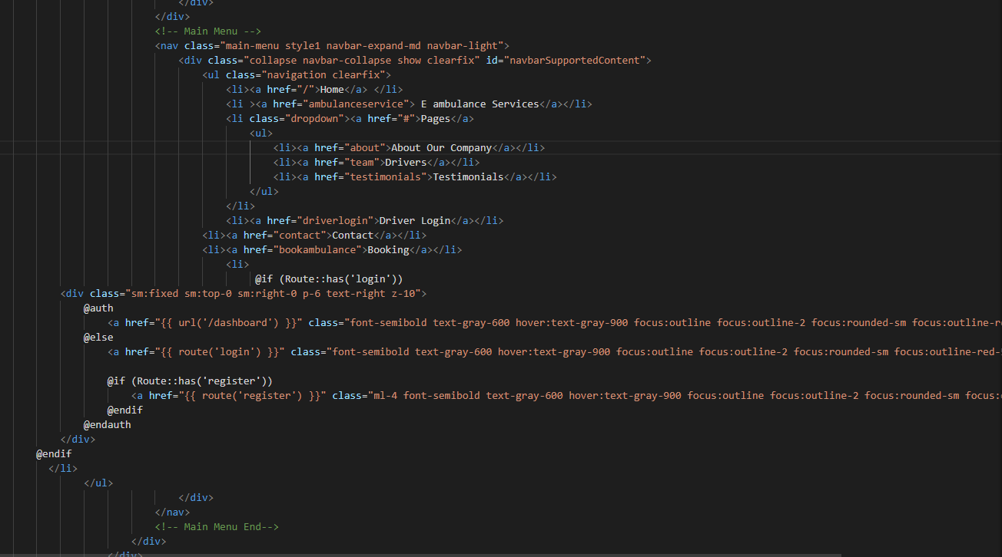

­

***Footer:***

This footer is also a part of (head_foot.blade.php)file .

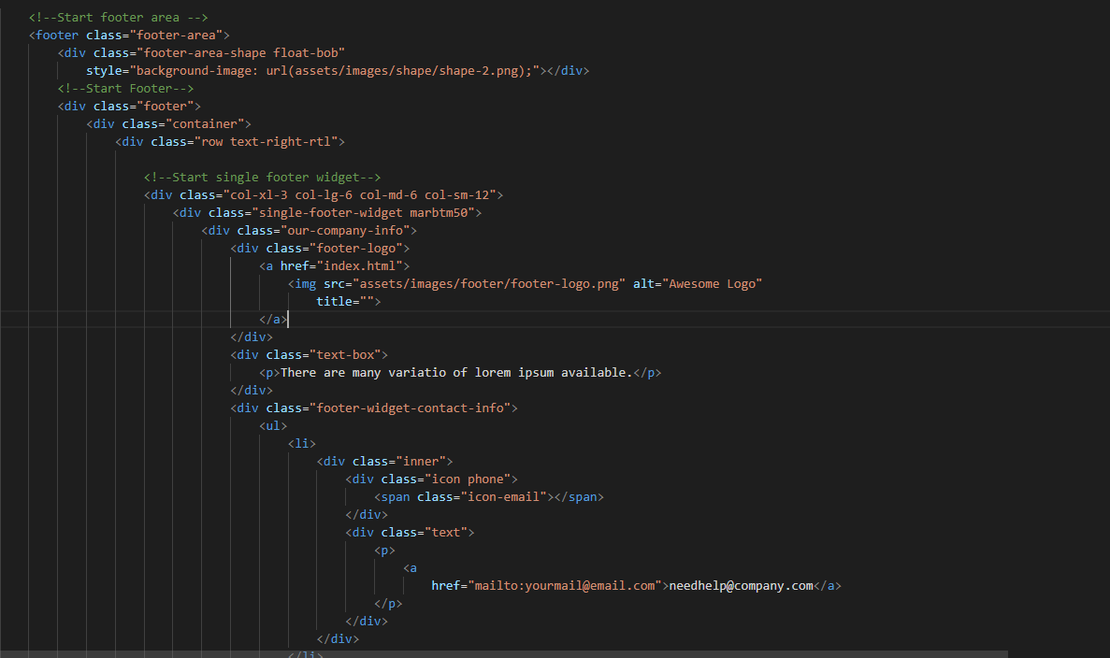

**Home Page:**

In this page user can see dynamic services and also get acknowledge by new blogs which are coming from admin dashboard .

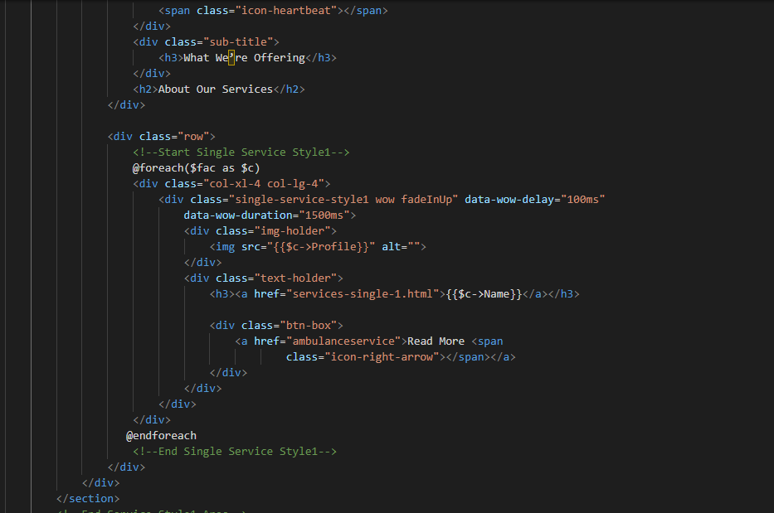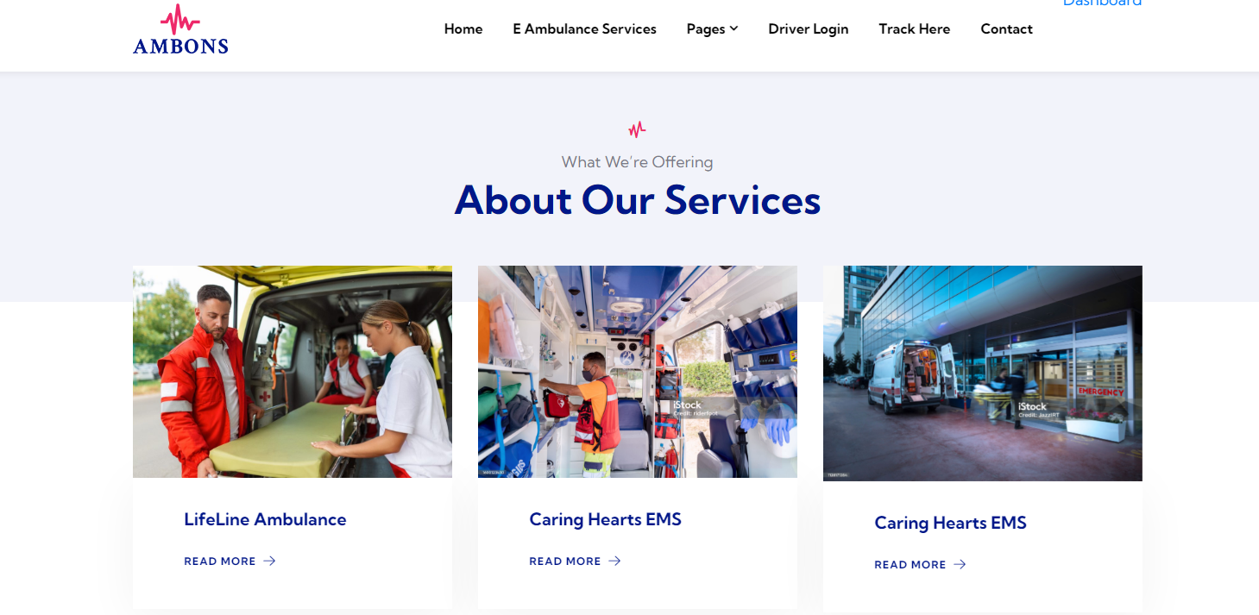

Blogs section in index.blade.php(home file).

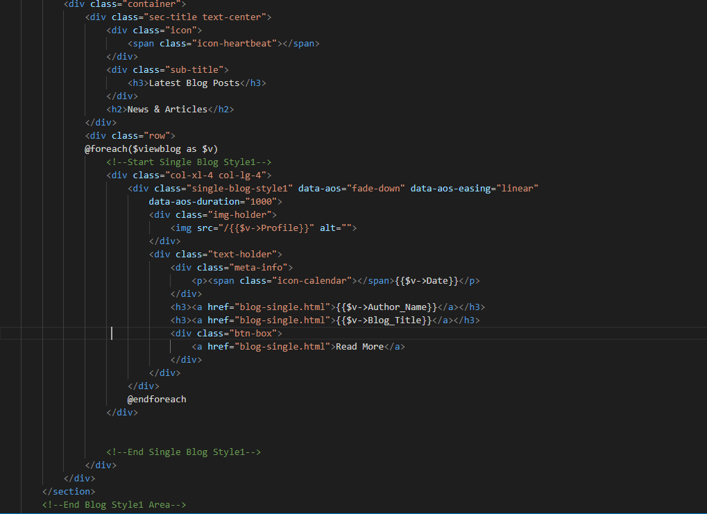

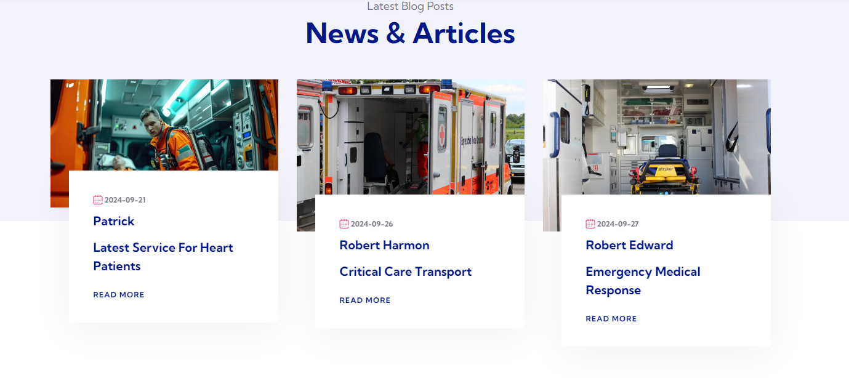

**About page:**

In this about page user can easily as we have mentioned the information and bio regarding our medical and ambulance staff who are not only reliable also professional when it comes to their job and their work **About Page:**

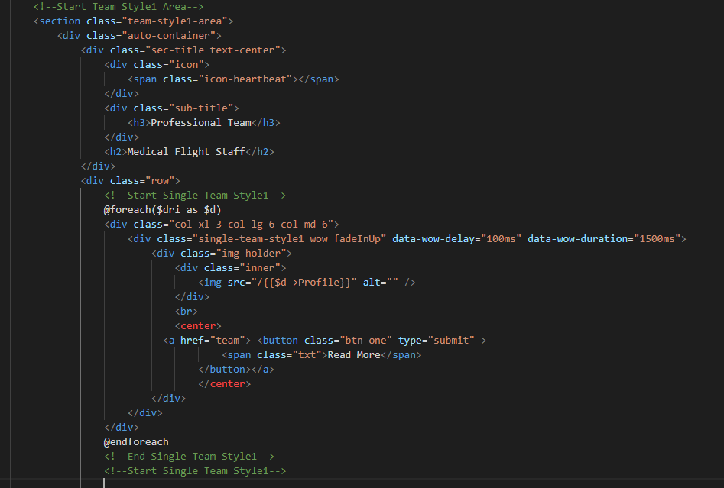

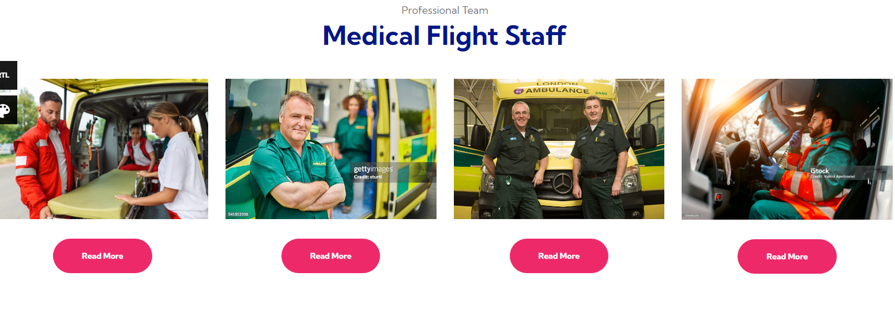

From this part user can be acknowledge of our service percentage

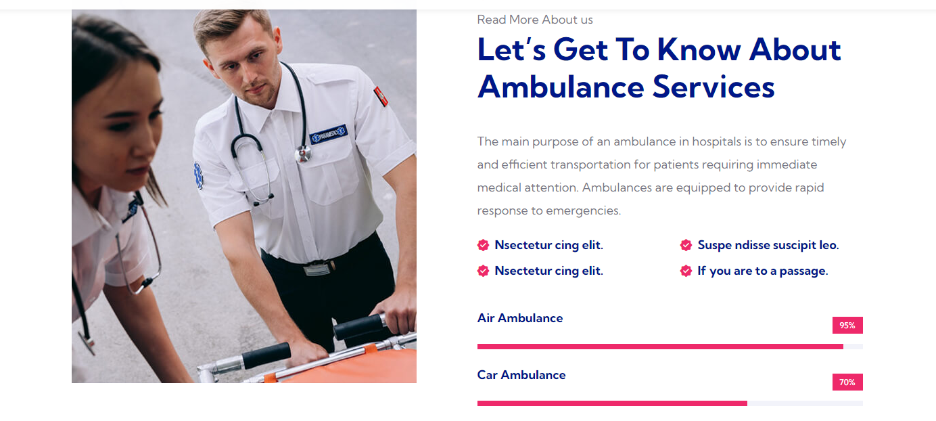

E ambulance Service Page:

In this page user can easily be aware about the description related to our services which we are providing to patients through ambulance.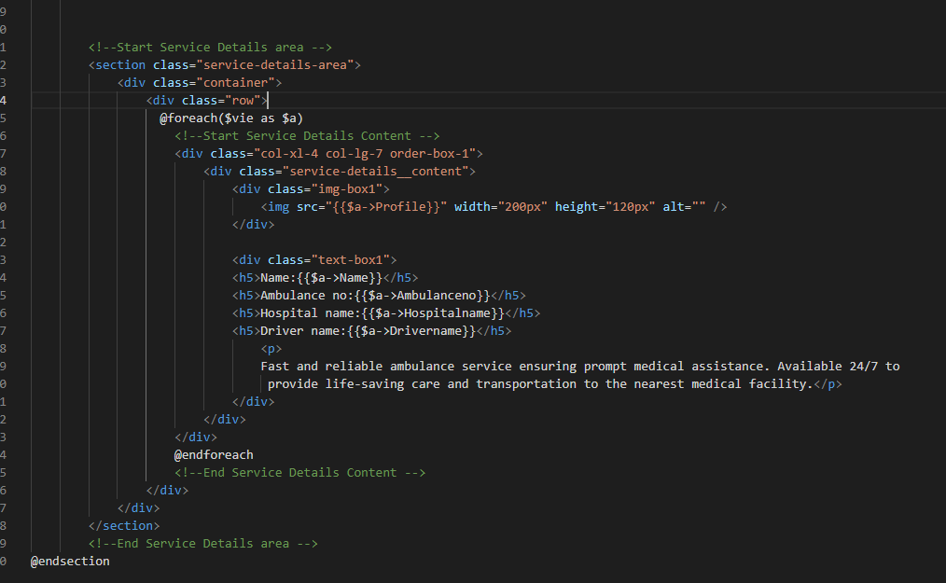

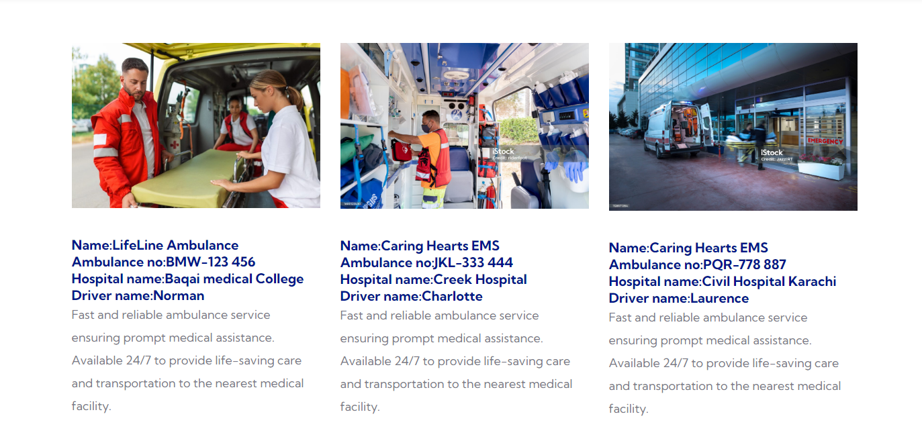

**Team Page:**

In this part of website user can easily get the info about our team members who are always ready to show their generosity and ready to help other.

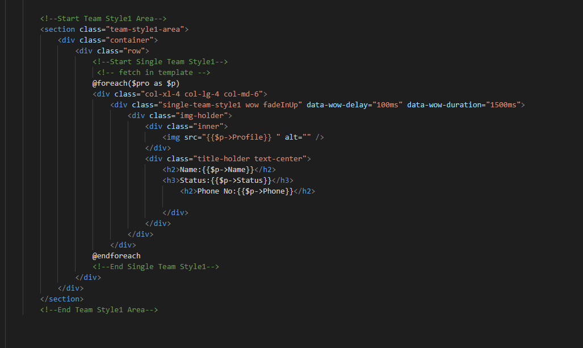

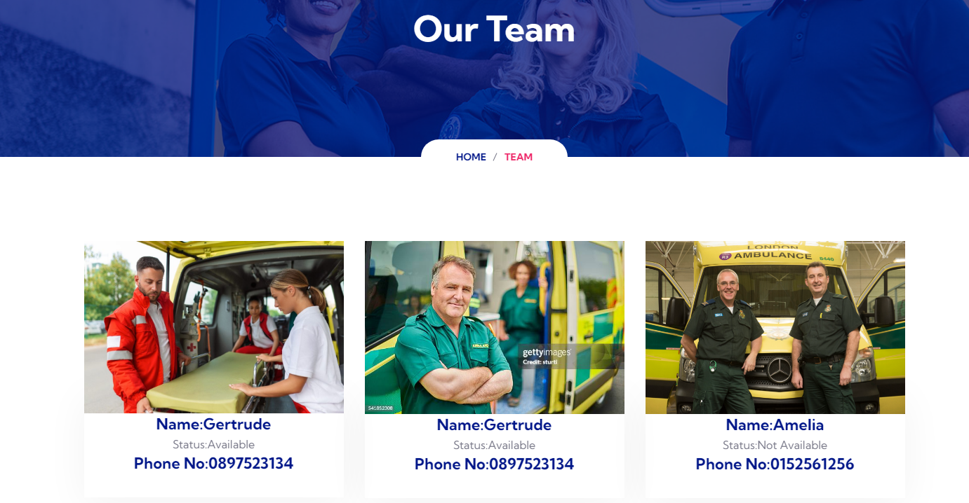

**Driver Login :**

From this page user can be easily get aware about the drivers and are able to chose the drivers of their own also they first have to login by putting their email address and password.

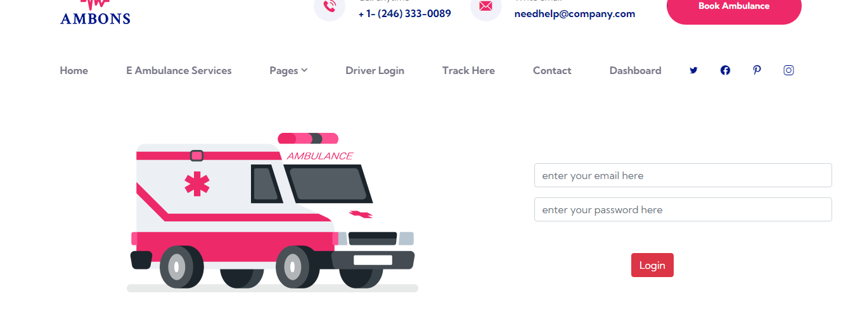

**Testimonials Page:**

From this page user can easily see the feedback they submitted after get a chance to receive our service and as a proof of their satisfaction

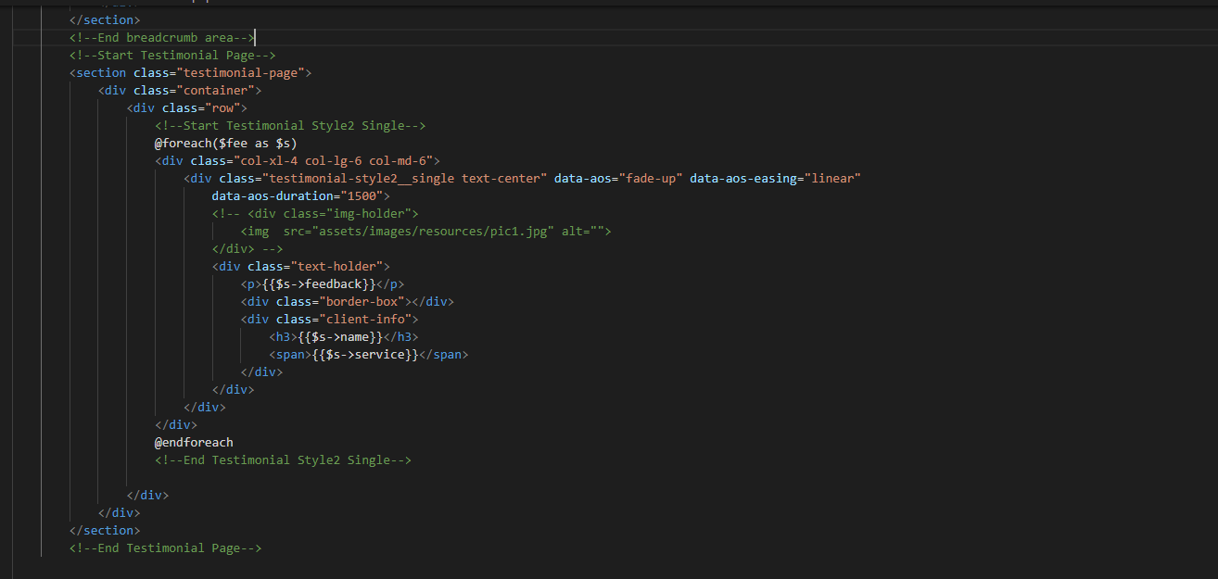

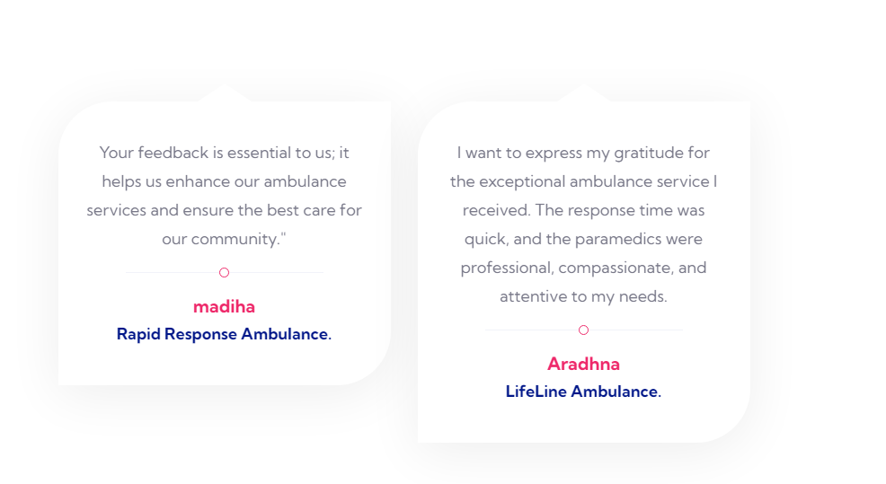

**Book Ambulance Page:**

In this page user can click book an ambulance button and then book ambulance

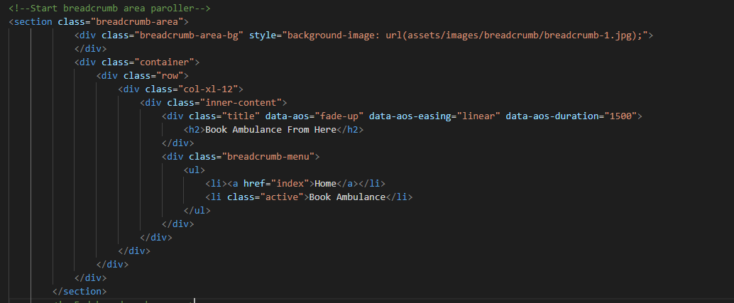

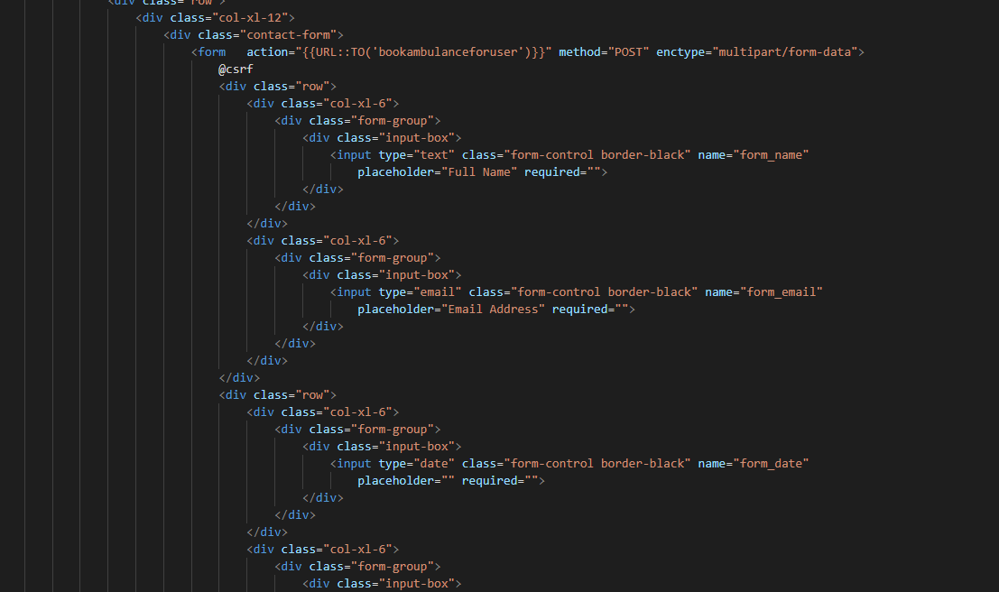

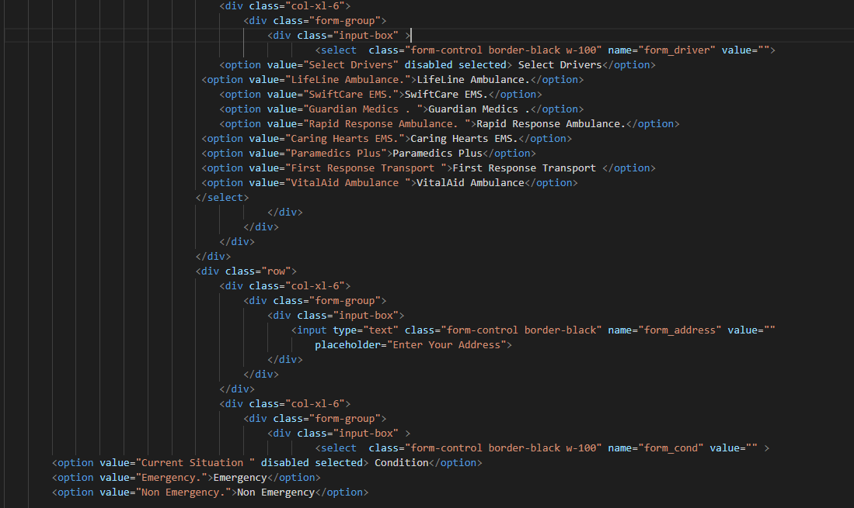

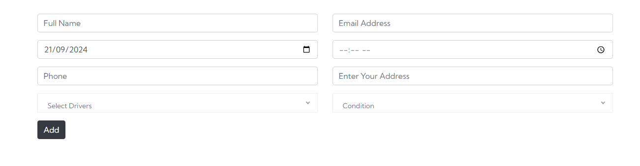

**Tracking Page:**

From this page user can easily pull up the information regarding their booking by putting their tracking id which they’ll get after booking the ambulance of their own choice.

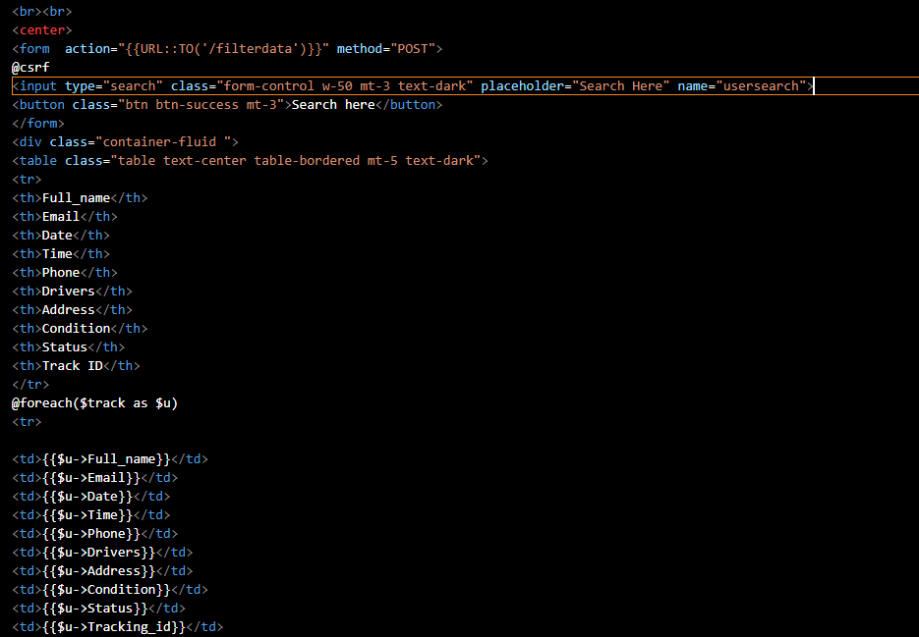

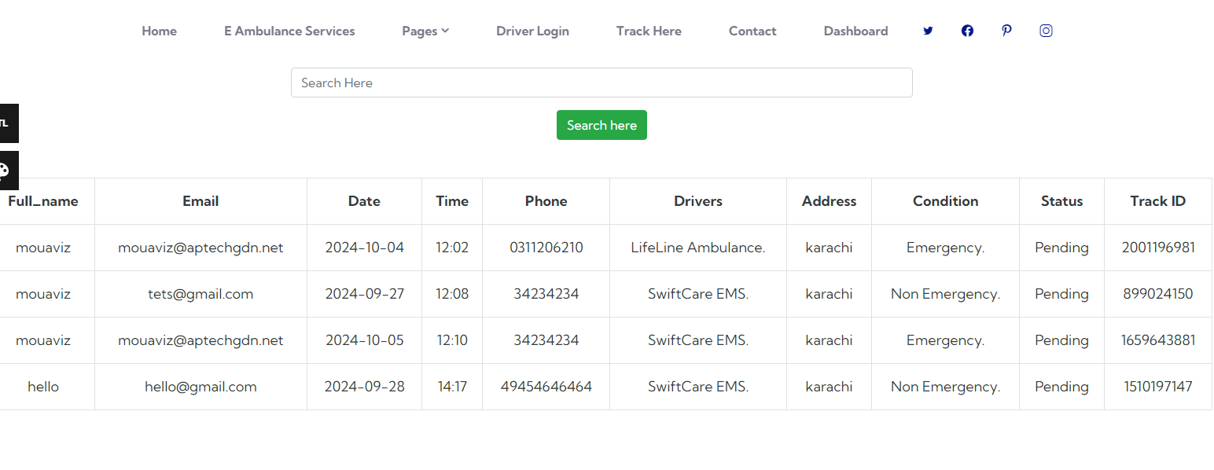

**Contact Page:**

In this page user have to leave the message by putting their some information in the given form so that an admin can see all contacts of our website users

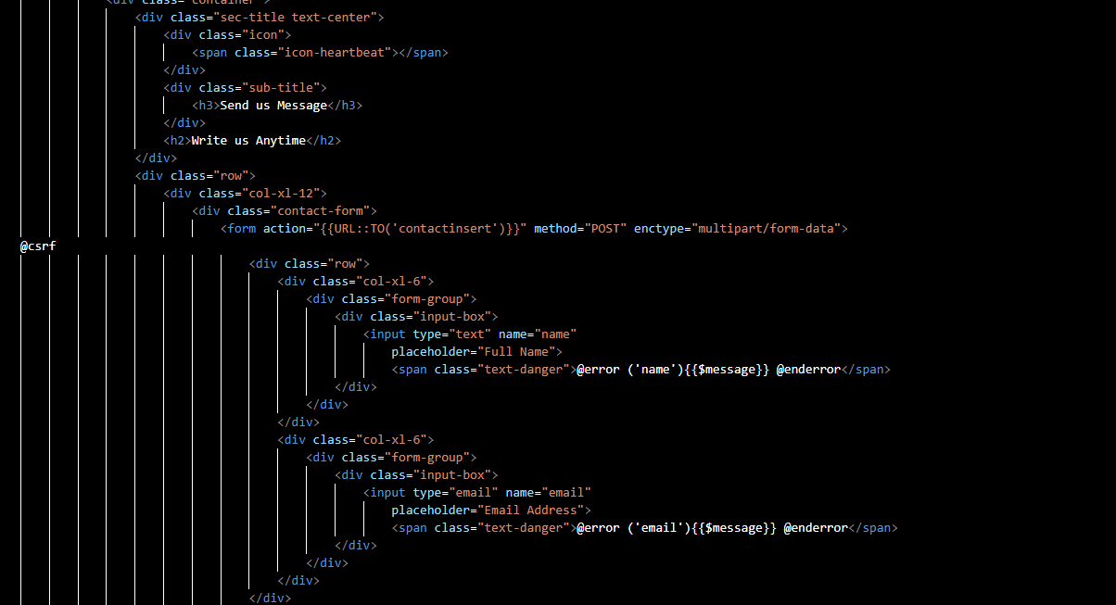

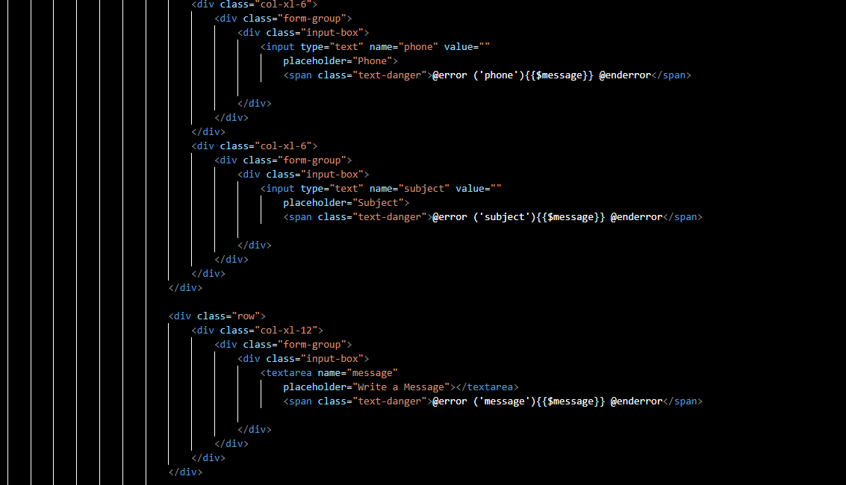

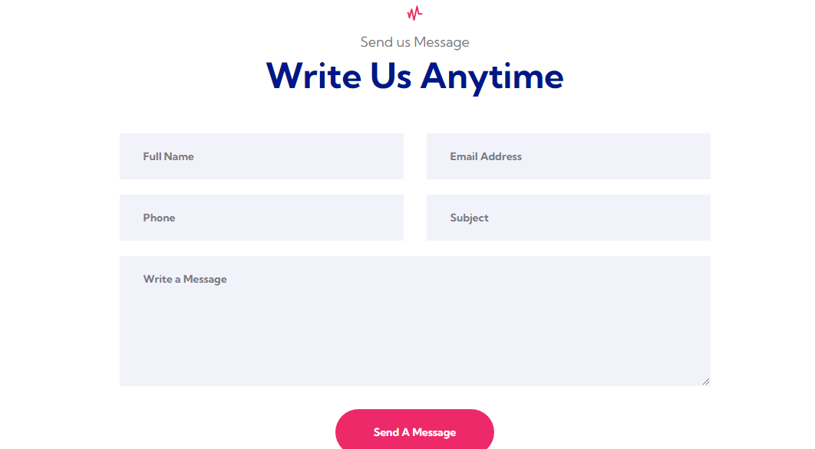

***Dashboard***

*There are 3 types of Dashboards:*

**Admin dashboard:**

* **Driver record:** here admin can insert new drivers also can see all records of our available driver
* **Feedback record**: here admin can see all the feedback received by users
* **Contact record:** here admin can see all contacts and and are able to delete as well
* **User data:** here admin are able to see users data also are able to delete and edit the role to go to any other dashboard like user and driver.
* **Booking record**: here admin can see their latest booking by users

Search ambulance: admin can search the data by names also can directly go to user dashboard

* **Add blog**: here admin can add blog and articles also can view it

**User Dashboard:**

* **Insert feedback:** here user can easily fill the feedback by giving us a survey also can view their own feedbacks
* **Contact record:** user can easily see their own contact information
* **Search ambulance:** user can easily search their ambulance by searching their names

**Driver Dashboard:**

* **Feedback:** driver can see feedback given from users on their services
* **Contact** : driver can see all contacts

**Admin dashboard:**

**Insert Drivers**:

In this section Admin can easily add Drivers.

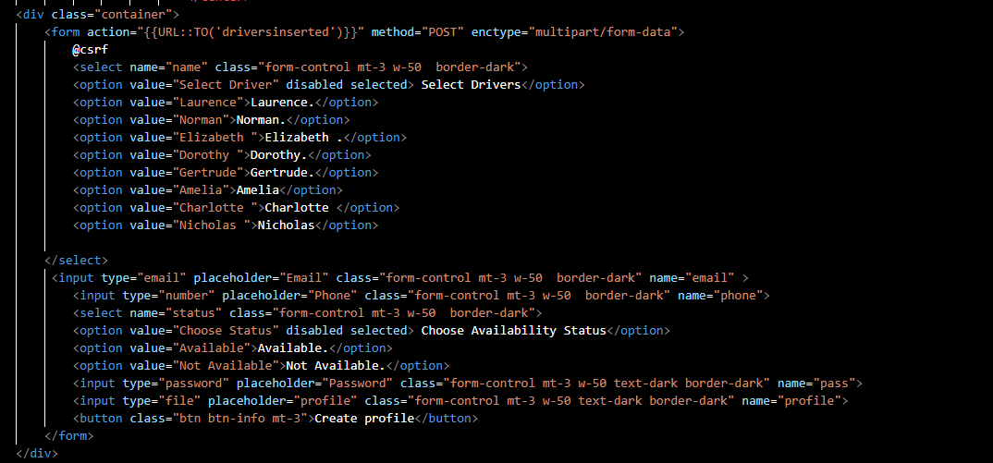

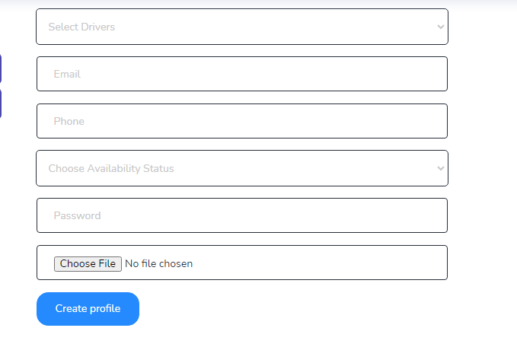

**View Drivers:**

In this section admin can easily view drivers data and also delete data.

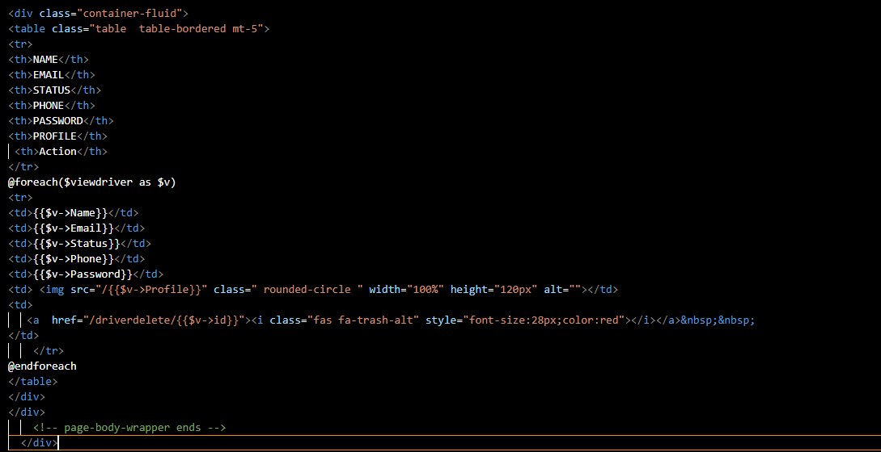

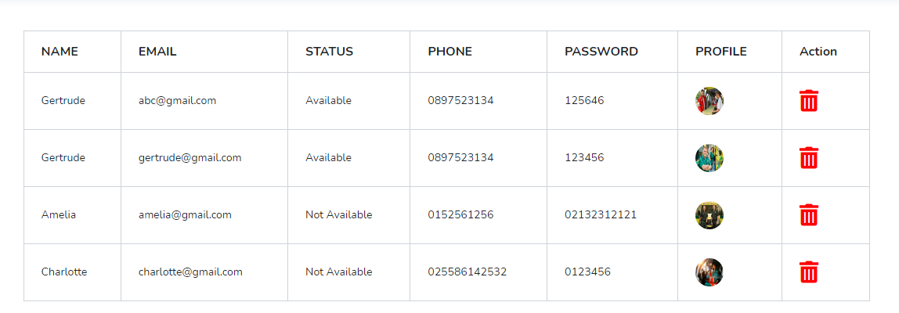

**Show feedback:**

In this section admin can easily view feedback data .

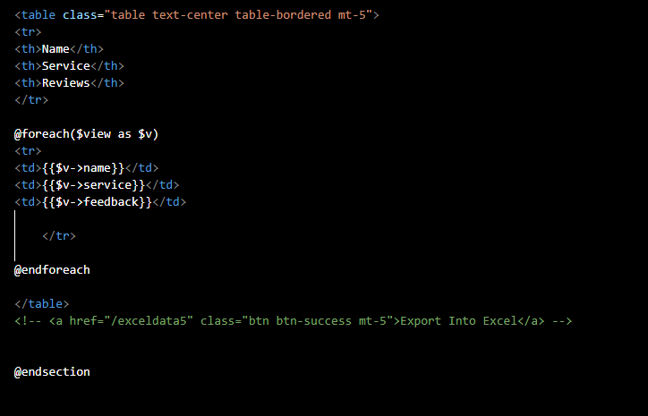

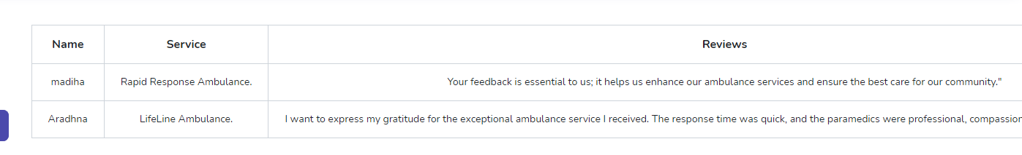

**Show Contact Data:**

In this section admin can easily view contact data and also delete data .

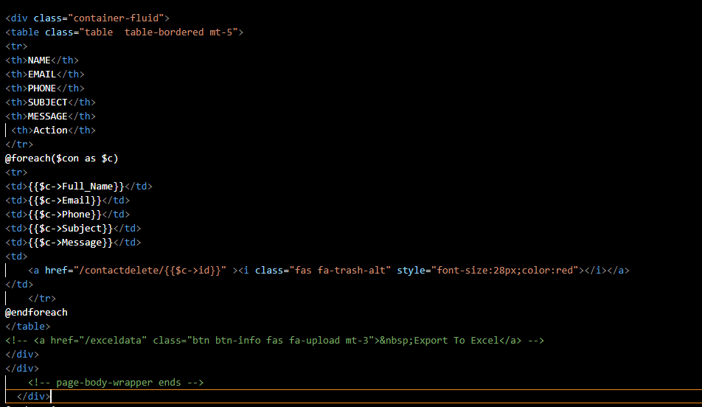

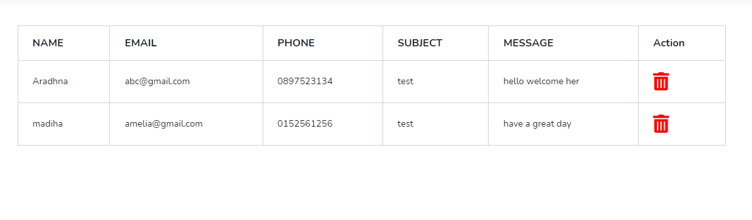

**Show User Data :**

In this section admin can easily view user data , delete data and update their user role .

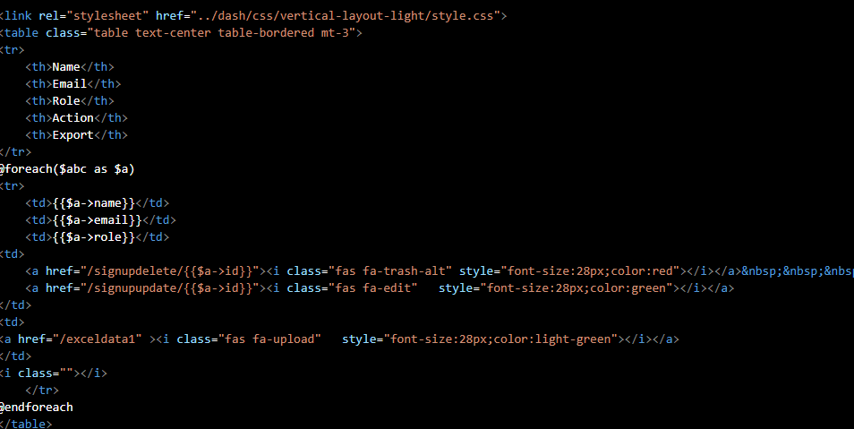

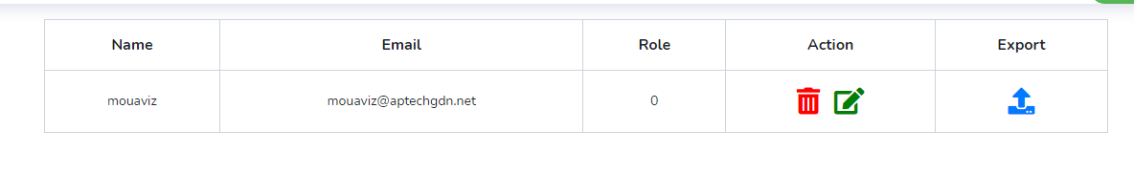

**Then admin click update icon and update your role.**

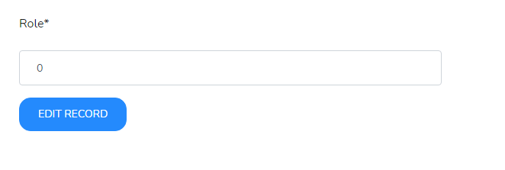

**Insert Ambulance:**

In this section Admin can easily add Ambulance with Profiles.

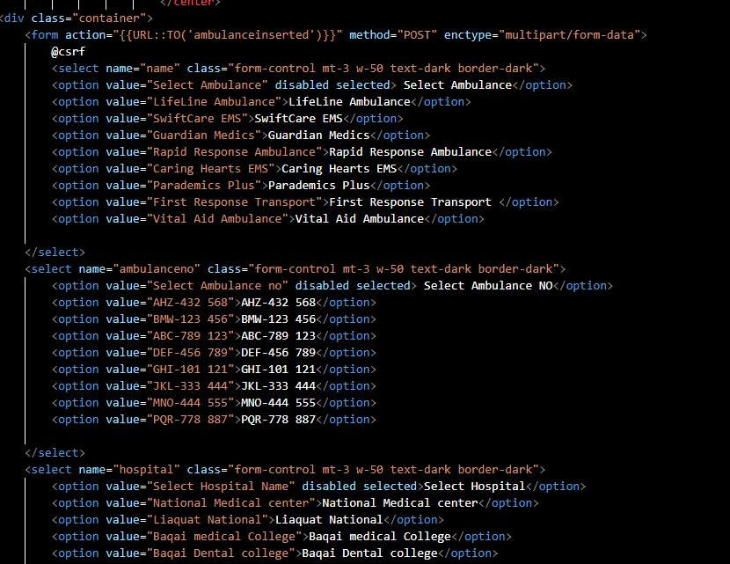

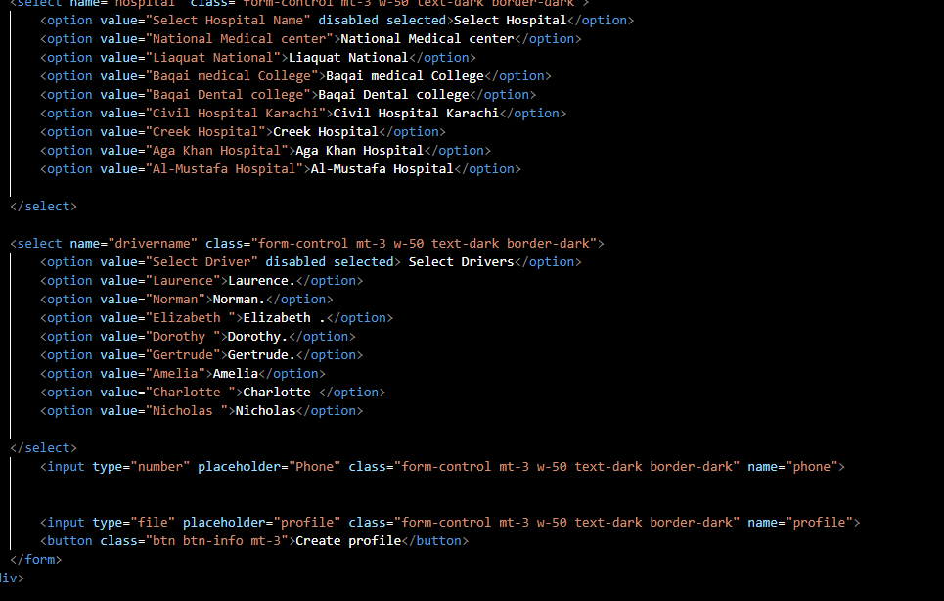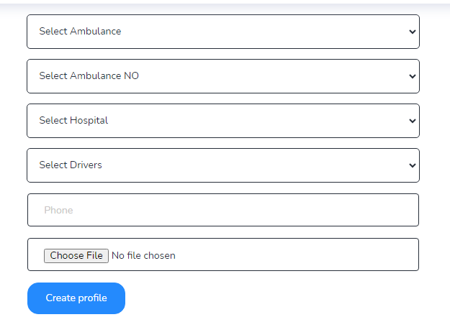

**Show Ambulance Data:**

In this section admin can easily view Ambulance data with profiles.

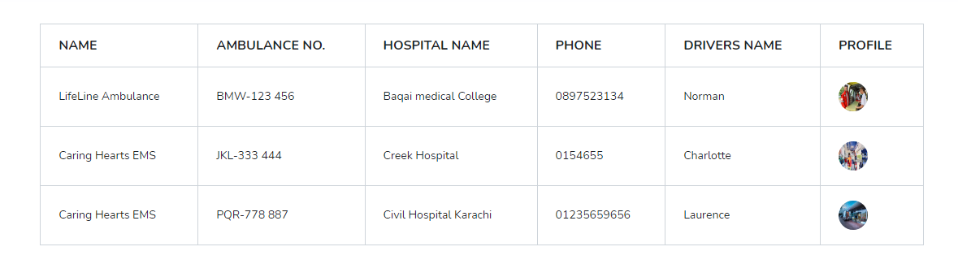

**Insert Blogs:**

In this section Admin can easily add blogs with Profiles and also delete data.

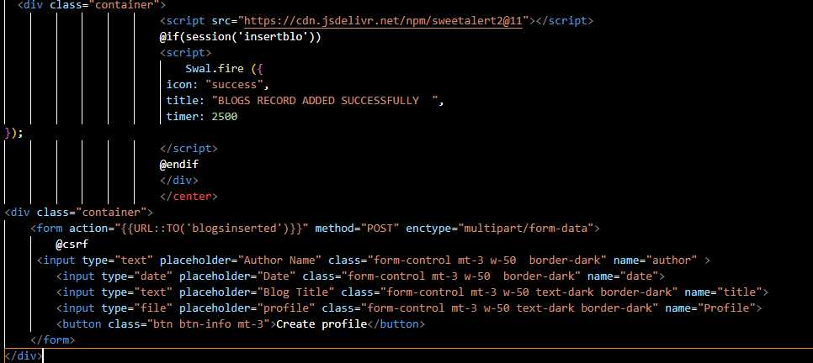

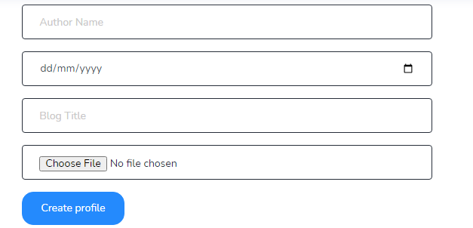

**Show Blog Data:**

In this section admin can easily view blog data with profiles.

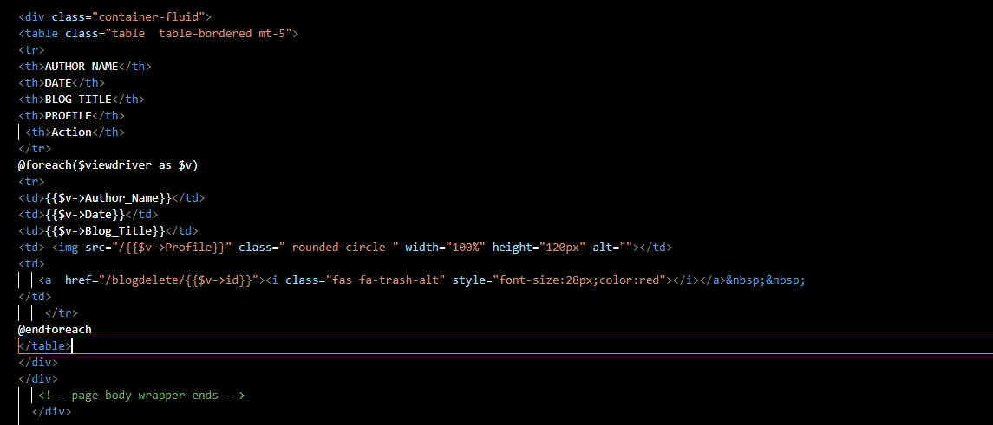

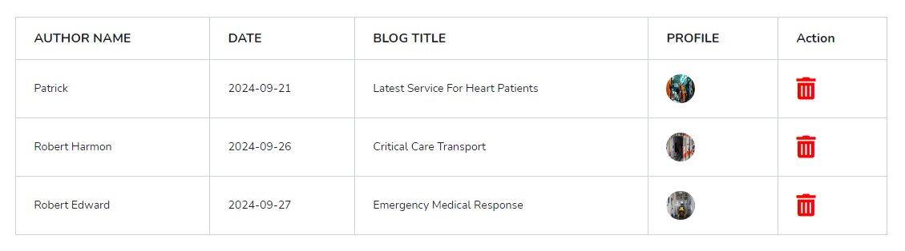

**User Dashboard:**

**Insert Feedback :**

In this section user can easily insert our ambulance reviews.

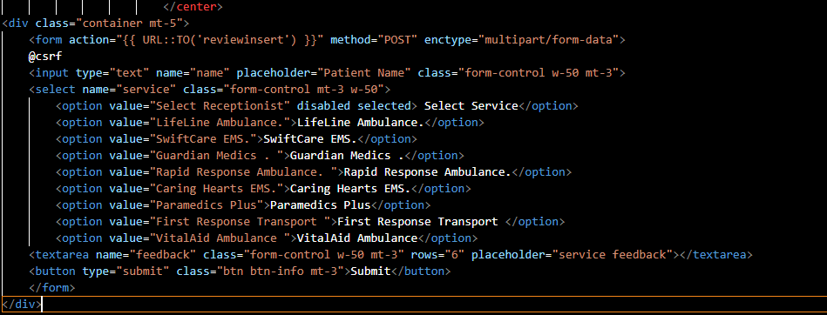

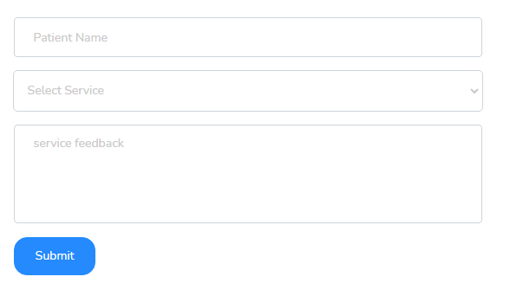

**Show Feedback:**

In this section user can easily view their reviews.

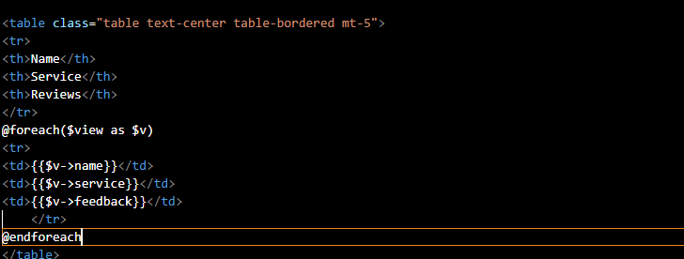

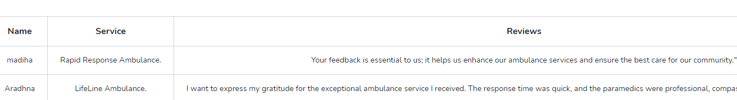

**Show Contact Data:**

In this section user can easily view contact data.

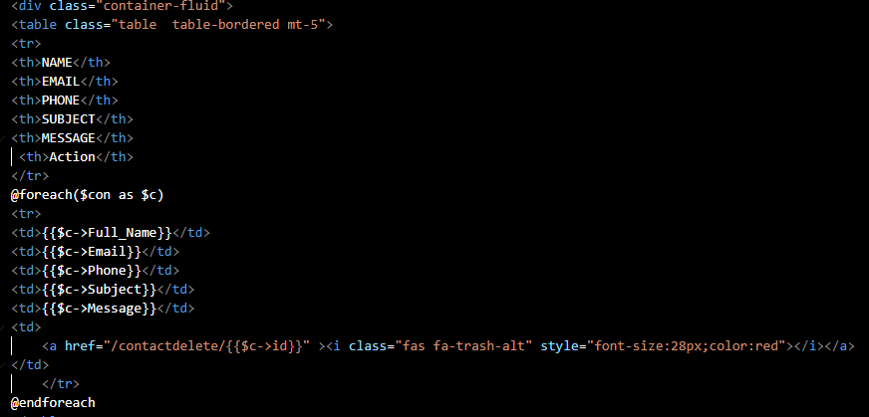

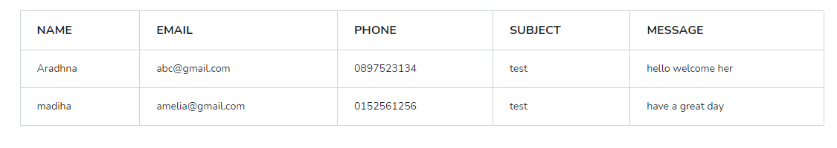

**Search Ambulance record:**

In this section user can easily search data with their names.

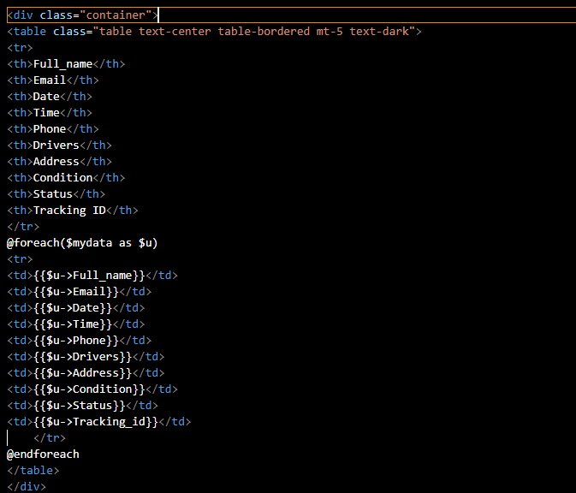

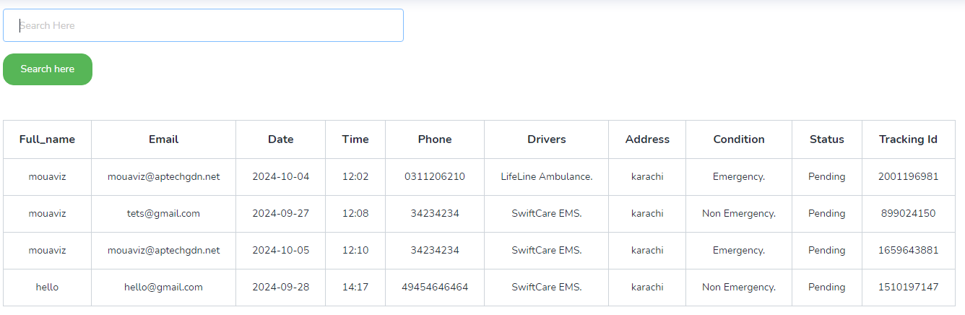

**User Dashboard:**

**Show Feedback:**

In this section driver can easily view their reviews.





**Show Booking data:**

In this section driver can easily show their patients booking.

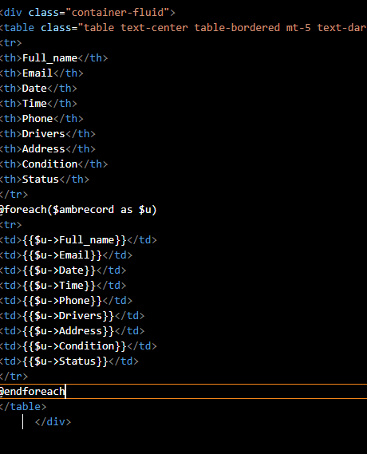

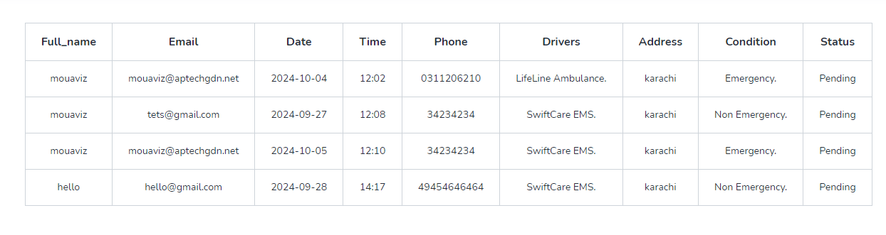

Controller 🡪 Admincontroller:

In this file admin made a functions which were the reason of ambitious and burdensome errors

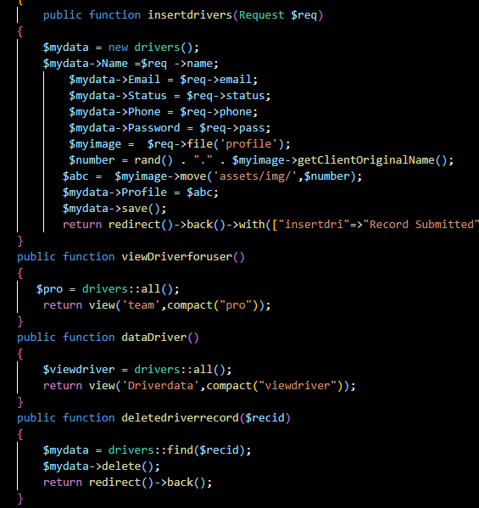

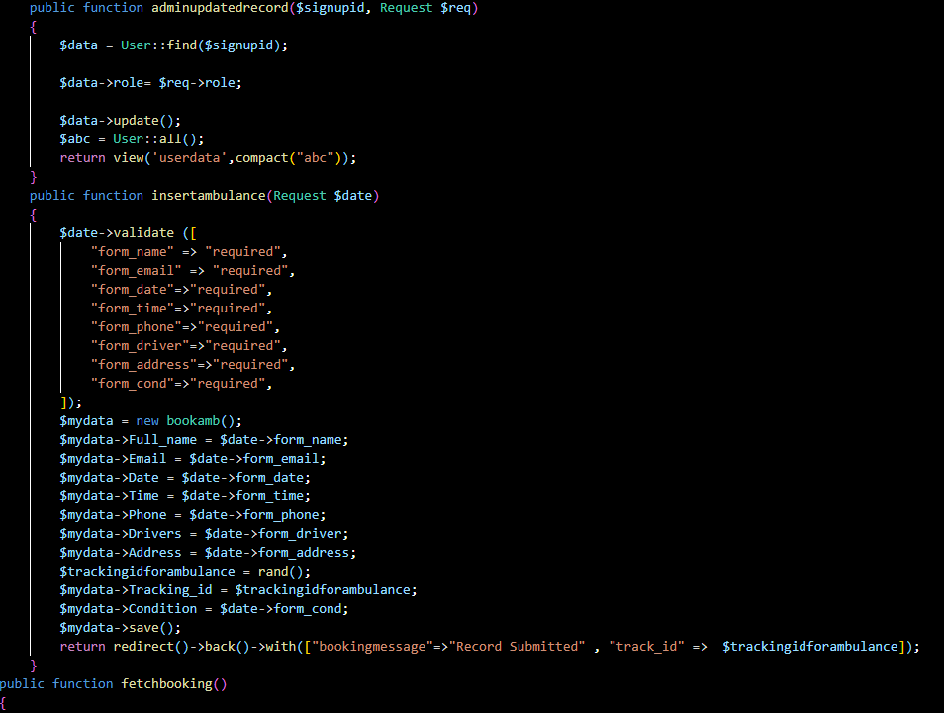

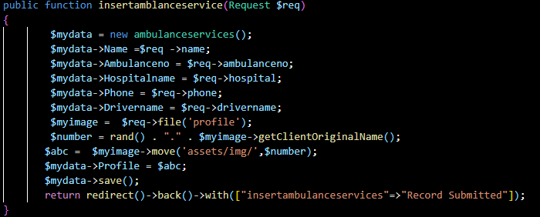

Routing(Web.php):

In this admin made a routes to let our functions of admincontroller run.

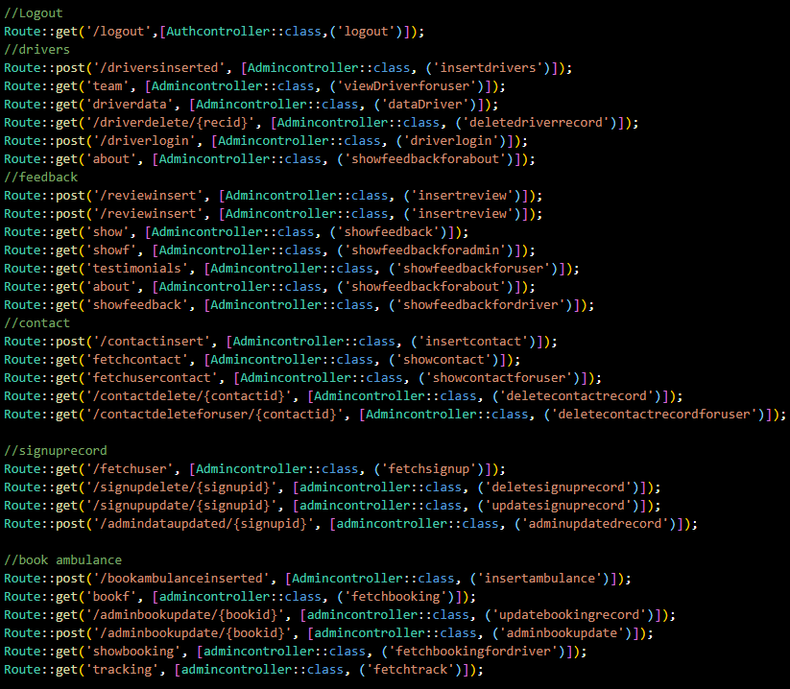

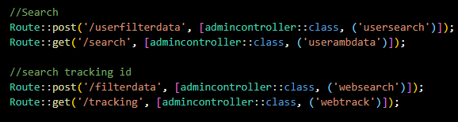

**sitemap regarding dashboard:**

***Database Design:*** 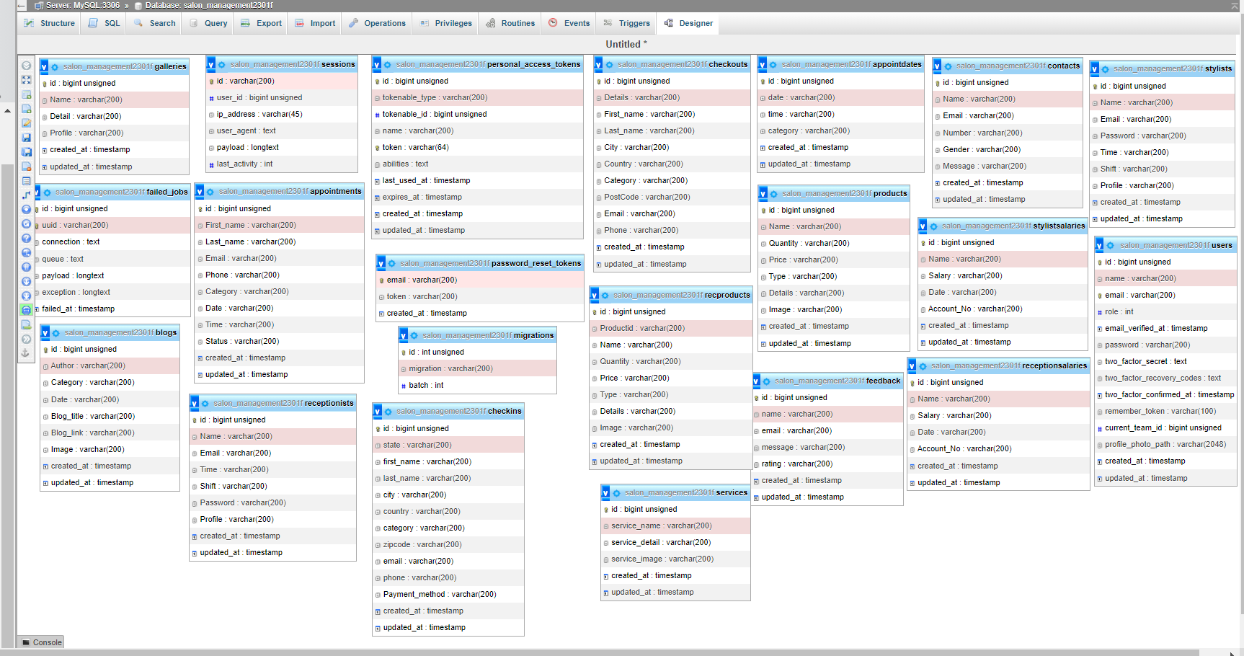

Show Services

Book Ambulance record (fetch and update)

Can see Patient’s feedback

nd fetch Driver’s record

Driver’s Dashboard

Show Fedback

Driver Data

Contact Data

User’s Dashboard

Show Booking and search ambulance data

eedback

Show Contact

Show Feedback

Show & Delete record of Contact

Insert and fetch Driver’s record

Admin Dashboard

**Thankyou So Much For Reading Our Documentation**